Source Data Mapping Approach to CDMV5.4

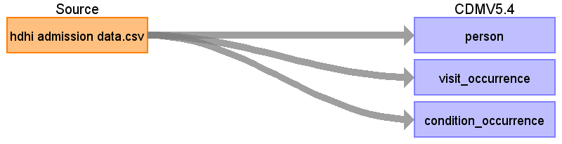

Table name: person

Reading from hdhi admission data.csv

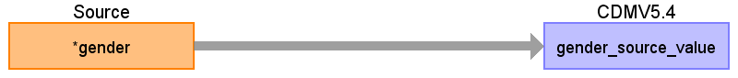

|  |  |  |  |
| --- | --- | --- | --- |
| Destination Field | Source Field | Logic | Comment |
| person_id |  |  |  |
| gender_concept_id |  |  |  |
| year_of_birth |  |  |  |
| month_of_birth |  |  |  |
| day_of_birth |  |  |  |
| birth_datetime |  |  |  |
| race_concept_id |  |  |  |
| ethnicity_concept_id |  |  |  |
| location_id |  |  |  |
| provider_id |  |  |  |
| care_site_id |  |  |  |
| person_source_value |  |  |  |
| gender_source_value | gender |  |  |
| gender_source_concept_id |  |  |  |
| race_source_value |  |  |  |
| race_source_concept_id |  |  |  |
| ethnicity_source_value |  |  |  |
| ethnicity_source_concept_id |  |  |  |

Table name: observation_period

Table name: visit_occurrence

Reading from hdhi admission data.csv

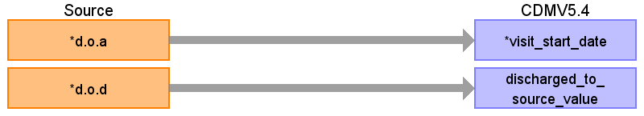

|  |  |  |  |
| --- | --- | --- | --- |
| Destination Field | Source Field | Logic | Comment |
| visit_occurrence_id |  |  |  |
| person_id |  |  |  |
| visit_concept_id |  |  |  |
| visit_start_date | d.o.a |  |  |
| visit_start_datetime |  |  |  |
| visit_end_date |  |  |  |
| visit_end_datetime |  |  |  |
| visit_type_concept_id |  |  |  |
| provider_id |  |  |  |
| care_site_id |  |  |  |
| visit_source_value |  |  |  |
| visit_source_concept_id |  |  |  |
| admitted_from_concept_id |  |  |  |
| admitted_from_source_value |  |  |  |
| discharged_to_concept_id |  |  |  |
| discharged_to_source_value | d.o.d |  |  |
| preceding_visit_occurrence_id |  |  |  |

Table name: visit_detail

Table name: condition_occurrence

Reading from hdhi admission data.csv

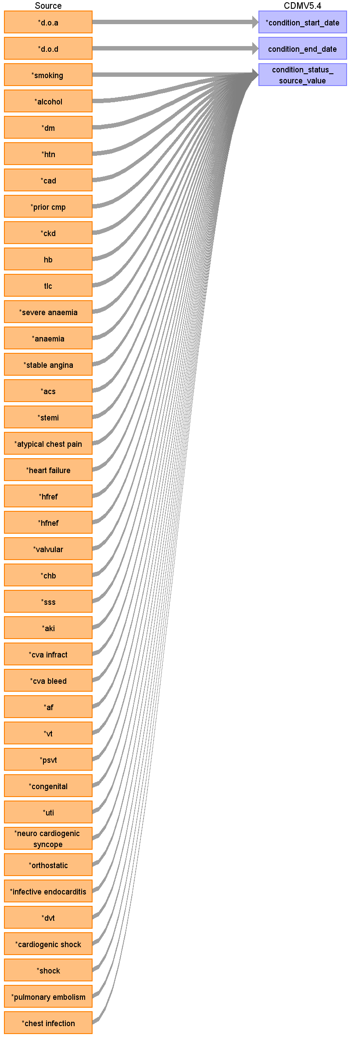

|  |  |  |  |
| --- | --- | --- | --- |
| Destination Field | Source Field | Logic | Comment |
| condition_occurrence_id |  |  |  |
| person_id |  |  |  |
| condition_concept_id |  |  |  |
| condition_start_date | d.o.a |  |  |
| condition_start_datetime |  |  |  |
| condition_end_date | d.o.d |  |  |
| condition_end_datetime |  |  |  |
| condition_type_concept_id |  |  |  |
| condition_status_concept_id |  |  |  |
| stop_reason |  |  |  |
| provider_id |  |  |  |
| visit_occurrence_id |  |  |  |
| visit_detail_id |  |  |  |
| condition_source_value |  |  |  |
| condition_source_concept_id |  |  |  |
| condition_status_source_value | smoking  alcohol  dm  htn  cad  prior cmp  ckd  hb  tlc  severe anaemia  anaemia  stable angina  acs  pulmonary embolism  chest infection  shock  cardiogenic shock  dvt  infective endocarditis  orthostatic  neuro cardiogenic syncope  uti  congenital  psvt  vt  af  cva bleed  cva infract  aki  sss  chb  stemi  valvular  hfnef  hfref  heart failure  atypical chest pain |  |  |

Table name: drug_exposure

Table name: procedure_occurrence

Table name: device_exposure

Table name: measurement

Table name: observation

Table name: death

Table name: note

Table name: note_nlp

Table name: specimen

Table name: fact_relationship

Table name: location

Table name: care_site

Table name: provider

Table name: payer_plan_period

Table name: cost

Table name: drug_era

Table name: dose_era

Table name: condition_era

Table name: episode

Table name: episode_event

Table name: metadata

Table name: cdm_source

Table name: cohort

Table name: cohort_definition

Appendix: source tables

Table: hdhi admission data.csv

|  |  |  |  |
| --- | --- | --- | --- |
| Field | Type | Most freq. value | Comment |
| ﻿sno | INT |  |  |
| mrd no. | VARCHAR | 256628 |  |
| d.o.a | VARCHAR | 01/01/2018 |  |
| d.o.d | VARCHAR | 09/01/2019 |  |
| age | INT | 65 |  |
| gender | VARCHAR | M |  |
| rural | VARCHAR | U |  |
| type of admission-emergency/opd | VARCHAR | E |  |
| month year | VARCHAR | Jan-19 |  |
| duration of stay | INT | 2 |  |
| duration of intensive unit stay | INT | 0 |  |
| outcome | VARCHAR | DISCHARGE |  |
| smoking | INT | 0 |  |
| alcohol | INT | 0 |  |
| dm | INT | 0 |  |
| htn | INT | 0 |  |
| cad | INT | 1 |  |
| prior cmp | INT | 0 |  |
| ckd | INT | 0 |  |
| hb | VARCHAR | 12.6 |  |
| tlc | VARCHAR |  |  |
| platelets | VARCHAR |  |  |
| glucose | VARCHAR |  |  |
| urea | VARCHAR | 27 |  |
| creatinine | VARCHAR | 0.8 |  |
| bnp | VARCHAR |  |  |
| raised cardiac enzymes | INT | 0 |  |
| ef | VARCHAR | 60 |  |
| severe anaemia | INT | 0 |  |
| anaemia | INT | 0 |  |
| stable angina | INT | 0 |  |
| acs | INT | 0 |  |
| stemi | INT | 0 |  |
| atypical chest pain | INT | 0 |  |
| heart failure | INT | 0 |  |
| hfref | INT | 0 |  |
| hfnef | INT | 0 |  |
| valvular | INT | 0 |  |
| chb | INT | 0 |  |
| sss | INT | 0 |  |
| aki | INT | 0 |  |
| cva infract | INT | 0 |  |
| cva bleed | INT | 0 |  |
| af | INT | 0 |  |
| vt | INT | 0 |  |
| psvt | INT | 0 |  |
| congenital | INT | 0 |  |
| uti | INT | 0 |  |
| neuro cardiogenic syncope | INT | 0 |  |
| orthostatic | INT | 0 |  |
| infective endocarditis | INT | 0 |  |
| dvt | INT | 0 |  |
| cardiogenic shock | INT | 0 |  |
| shock | INT | 0 |  |
| pulmonary embolism | INT | 0 |  |
| chest infection | VARCHAR | 0 |  |